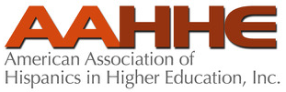
Strategic Planning Request for Proposals

Due Date for Proposal Receipt is March 13, 2023, 5:00 PM ET.
Late Arrivals and Mail Submissions Will Not Be Accepted.

- Purpose of Consultancy

The American Association of Hispanics in Higher Education (AAHHE) is embarking on a strategic planning process for which it is requesting proposals from interested, qualified, and experienced individuals, organizations, or companies that provide strategic planning, development, and facilitation services.

Recipients of this Request for Proposals (RFP) are encouraged to thoroughly explore the AAHHE website (www.aahhe.org) to gain an understanding of the organization. This RFP includes links to information on the website.

- Goal

The primary goal of the strategic planning contract will be to facilitate, manage, and bring expert knowledge with tangible examples to the strategic planning process for the AAHHE Board, volunteer leadership, staff, and members. In particular, through its strategic planning process, AAHHE looks to ensure that its vision, mission, and core values align with the needs of the organization, its members, Latinx/a/o/é communities, and others that it serves. The strategic plan will identify synergies between research, programs, and other activities to help establish and advance the organization’s goals. Through a competitive proposal process, AAHHE will select an individual, organization, or a company to serve as the consultant on this project.

- Background/Organizational Overview

- Background

AAHHE is a 501(c)(3) nonprofit organization. As a national Latinx/a/o/é and equity-centered, higher education association, AAHHE engages and aligns with multiple communities, partners, and stakeholders to advance its mission. Partners and collaborators include industry, governmental programs, foundations, Latinx/a/o/é colleges and universities, non-profits, and advocacy groups.

While the Latinx/a/o/é population is the largest ethnic minority population in the United States of America, Latinx/a/o/é are still highly underrepresented in the undergraduate and graduate enrollments and graduation rates.

Historically, Latinx/a/o/é faculty in tenure-track positions has been underrepresented in colleges and universities.

- Organizational Chart
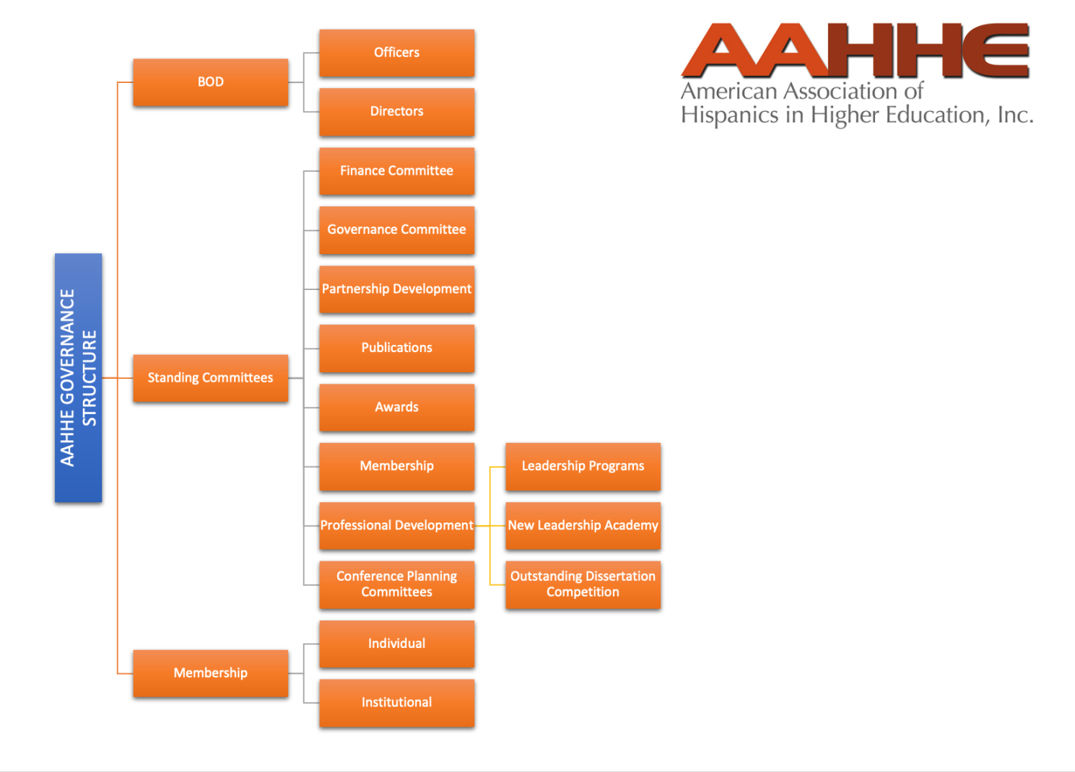
- Vision

AAHHE seeks a radical shift in equity policies and leadership among higher education institutions to effectively address the needs of Latinx/a/o/é communities and empower the Association to strive for academic success, knowledge production, and artistic creation to advance social change that creates opportunities for all.

- Mission

AAHHE prepares, supports, and advances Latinx/a/o/é students, faculty, staff, administrators, and community members through higher education to participate, lead, and influence in our society.

- Core Values

AAHHE’s core values are of paramount importance to the association’s leadership, membership, and organizational partnerships. We strive for social change through collective action rooted in values of justice, anti-racism, and empowerment. As agents of change, we are committed to:

- Advocate for Latinx/a/o/é communities, recognizing how individual and group differences contribute to inclusive concepts, leadership, knowledge, and experiences that are the foundation of a high-quality education.
- Engage with equity and justice actively and intentionally across all our communities in higher education to increase awareness, expertise, and advocacy of Latinx/a/o/é success.
- Prioritize inclusionary praxis to support Latinx/a/o/é students and professionals in educational pathways.

- Strategic Plan – Individuals, organizations, or companies selected as finalists will be provided with a copy of AAHHE’s current strategic plan.
- Membership

AAHHE is a professional association of individual and institutional members dedicated to advancing educational opportunities for different sectors of Latinx/a/o/é communities.

Individual membership categories include administrators, faculty, other professional, graduate students, and undergraduate students. Individual membership benefits can be found on the AAHHE website.

Institutional membership includes universities and colleges of any size. Institutional membership benefits can be found on the AAHHE website.

Membership applications for both the individual and institutional membership categories can be found on the AAHHE website.

AAHHE’s membership has remained steady for many years until the beginning of 2020 during the Covid-19 pandemic when the association saw a decline in membership. In mid-2021, AAHHE saw a steep rebound in both its individual and institutional members.

- Financial Health

Over the past four years, AAHHE’s annual budget has ranged between $329,000 to $540,000. The largest dip in budget occurred in 2021 during the Covid-19 pandemic as AAHHE transitioned its annual conference, one of the key revenue producers, from an in-person to virtual event.

- Governance

The AAHHE Board of Directors has the collective power, by majority vote, to manage and control the affairs and assets of the Association. The Board of Directors consists of 18 Directors. Up to 16 members of the Board are appointed by the existing Directors for a three-year term following nomination and vetting processes. Two members-at-large (Graduate Student Member At-large and Faculty Member At-large) of the Board of Directors are members of the Association and are elected by the membership. The Board meets quarterly and at an annual retreat. Board members’ terms run July 1 – June 30.

An Executive Committee is comprised of six officers of the AAHHE Board (Chair, Chair-elect, Immediate Past-chair, Treasurer, Treasurer-elect, and Immediate Past-treasurer. The Association’s Executive Director serves as an ex-officio member of the Executive Committee.
During the intervals between the meetings of the Directors, the Executive Committee shall have and may exercise all the powers of the Directors in the management of the business and affairs of AAHHE in all cases in which specific directions shall not have been given by the Board of Directors.

- Operations Management/Staffing

The Board of Directors contracts with an Association Management Company (AMC) to manage the daily operations of the organization including fiscal management, marketing and public relations, membership, and program offerings, i.e., professional development, signature programs, awards programs, and regional and annual meetings.

The AMC liaison serves as the Executive Director of AAHHE, with the approval and at the will of the Board with the following responsibilities:

- Managing the daily operations of the Association;
- Serving as Secretary of the Association’s Board of Directors;
- Serving on committees in an ex-officio capacity;
- Performing other duties as the Chair or the Board may prescribe.

- Major Events/Meetings

  - Annual Conference:

The 2023 annual conference is scheduled for March 1 – 3, 2023 at the College of Southern Nevada, North Last Vegas Campus in Las Vegas, NV and will be offered as a hybrid event. Annual conference attendance is approximately 300 – 400.

Conference Highlights – The conference showcases signature lectures (Tomás Rivera Lecture, Medical/STEM Lecture, and other commissioned featured sessions), as well as Best Scholarly Paper Award, AAHHE -ETS Outstanding Dissertation Competition, AAHHE Awards, and Book of the Year Awards.

Previous Conference Formats

2020 – In person
2021 – Virtual
2022 – Hybrid
2023 – In person, live-streamed general sessions

For 16 years, AAHHE hosted its annual conference at large hotels. In 2022, the hosting model for the conference was changed from a hotel to an educational institution, i.e., college or university. Future annual conferences will continue to be hosted at an educational institution, rather than a hotel.

Additional Conference Information – Visit the AAHHE website for more information about AAHHE’s 2023 Conference and past conferences.

  - ETS/AAHHE Undergraduate Fellowship Program: The Undergraduate Fellowship Program aims to increase Latinx/a/o/é undergraduate students’ knowledge and understanding of post-baccalaureate options and career readiness through workshops and professionalization. The program provides strategies to assist fellows in achieving their academic and professional goals, exposes undergraduate student fellows to the importance of research, and builds a community and network of Latinx/a/o/é mentors and scholars. This year, 2023, is the program’s inaugural year.

  - Graduate Student Fellowship Program: The AAHHE Graduate Student Fellowship Program (GSFP) prepares Latinx/a/o/é doctoral scholars for successful careers in academia. The program also provides support to Latinx/a/o/é scholars interested in pursuing careers within administration and policy in postsecondary education. The program builds community and network with other Latinx/a/o/é scholars and provides strategies to assist scholars in achieving their educational and professional goals in addition to constructive feedback on graduate student fellows’ research.

Graduate student fellows have the opportunity to attend AAHHE’s conference where they are introduced to Latinx/a/o/é professors and administrators from across the nation and are provided guidance, instruction, and mentors to help them navigate the complexities of higher education. Over 300 doctoral students have participated in this program.

  - Faculty Fellowship Program: The AAHHE Faculty Fellowship Program (FFP) prepares Latinx/a/o/é faculty for successful careers in academia and beyond by increasing the number of tenured and promoted Latinx/a/o/é faculty. The program is geared towards new faculty who are beyond their first year on the tenure-track. It provides strategies to assist tenure-track faculty in achieving their scholarly and career goals; builds community and network with other Latinx/a/o/é faculty; and develop future leaders who are dedicated to uplifting their communities.

  - New Leaders Academy: The New Leadership Academy Fellowship Program (NLA) is a partnership between the University of Utah and AAHHE. The program’s learning objectives draw upon traditional leadership theory and contemporary scholarship that investigate the roles of leaders under highly contested and complex conditions. Fellows are chosen each year, and they participate in tailored programs and activities, which include online learning modules and discussions, an interactive case study simulation, written reflections, and coaching sessions throughout the Fellowship.

  - Tomás Rivera Lecture: The Tomás Rivera Lecture is a highlight of each annual national conference, drawing on some of the best-known experts to speak to issues and concerns facing our nation and our institutions of higher education.

  - Medical/STEM Lecture: Another highlight of the annual national conference, the Medical/STEM Lecture, spotlights a prominent and established scholar, leader, or icon in the medical or science disciplines.

  - Awards Program: Through its renowned awards program, AAHHE celebrates and recognizes the expertise, energy, productivity, and contributions of Latinxs/a/o/é in higher education. The AAHHE Awards Program consists of eight awards in different categories. The awards are presented annually at a special luncheon at the conference.

  - Book of the Year Awards: The Books of the Year Awards are bestowed upon four recipients in celebration of Latinx/a/o/é culture, history, and research excellence and are presented to Latinx/a/o/é authors to celebrate and recognize their contributions to higher education. AAHHE acknowledges and honors the power of the written word to share the Latinx/a/o/é experience and celebrates the Latinx/a/o/é culture, history, and research excellence. The AAHHE Books of the Year Awards recipients' accomplishments are at the highest levels of literature and scholarship. The AAHHE Books of the Year Awards in four categories are presented at the annual conference. No other higher education organization provides these significant awards.

  - AAHHE - ETS Latinx Student Success Institute: The AAHHE - ETS Latinx Student Success Institute is presented at the annual conference by the Educational Testing Service (ETS) and AAHHE. Noted scholars and practitioners present research, showcase programs that work, and discuss with participants how to implement retention programs.

  - Outstanding Dissertation Competition & Awards: Since 2008, ETS and AAHHE have joined together to offer the Outstanding Dissertation Competition and Awards. The top three place winners showcase their dissertation during one of the Conference’s concurrent sessions.

- Professional Development

- Community College Institute – The Community College Institute (CCI) is an annual professional development program designed to provide participants with topics relevant to community colleges and the application to their own professional careers. The Institute showcases Latinxs/a/o/é who are leading community colleges in different administrative roles. The invited speakers share their own experiences, provide lessons learned in their journeys and tools that will help future community college administrators. The Institute touches upon the need to develop competencies in balancing institutional history with the mission and vision of the community college; and how to use data to improve student success, create a student-centered culture, and establish an institutional infrastructure that builds talent and institutional capacity for sustainability.

- Leadership Institute – The AAHHE Leadership Institute is designed for graduate students, administrators, faculty, and decision-makers considering career advancement in higher education. The Institute invites Latinx/a/o/é, extraordinary leaders in higher education who have made a mark in advancing racial equity and building partnerships for the good of the community. Speakers share perspectives on their career journeys, what has made a difference along the way and has inspired and informed their worldview as leaders, and what values and hopes have motivated them. Speakers are also invited to reflect on the role their cultural heritage has played in their endeavors.

- Webinars – AAHHE features monthly online seminars that enable individuals to stay up-to-date on current trends and topics and engage in live learning experiences without leaving their desk. For example, AAHHE features hands-on webinars to highlight practical skill-building such as writing workshops, as well as research dissemination (e.g., Outstanding Dissertation Competition winners). Other webinar are more informative such as NSF HSI webinars.

- Project Description/Scope of Work

The AAHHE leadership anticipates that this strategic planning engagement will require the following from the consultant:

- Management of project tasks.
- Design and execution of a strategic visioning and comprehensive planning process.
- Develop an actionable strategic plan, including projected budget implications from implementation.
- Develop recommendations regarding the plan’s implementation, communication, and socialization with membership.

It is expected that these tasks will be accomplished through a combination of activities, including:

- Historic and future-focused research including, but not limited to: Industry trend analysis and marketplace assessment.
- Competitive analysis (organizational and product/service) and benchmarking AAHHE with other similar sized non-profits, particularly higher education, minority-focused associations.
- SWOT analysis or other framework for identifying strengths and opportunities.
- Focus groups, listening tours, interviews, surveys and/or any other methods that will be useful in receiving member input.
- Facilitated group meetings with the Board and staff to create consensus regarding a strategic vision and plan. To keep costs at a minimum, it is recommended such meetings be conducted virtually.
- Develop new or validate current AAHHE mission and vision.
- Clearly define the roles of facilitator, AAHHE Board, and staff.
- Help Board identify and prioritize most important areas of focus for AAHHE.
- Incorporate input from a range of stakeholders (members, industry partners, volunteer leaders, etc.) through use of interviews, surveys, etc.
- Create plan that allows for flexibility.
- Develop goals in support of AAHHE’s vision and mission.
- Clearly define appropriate outcomes and success metrics.
- Create dashboard for tracking and evaluating plan success.
- Create a timeline and define clear steps for implementation.

- Timeline

RFP Release Date | February 15, 2023
RFP Responses Due | March 13, 2023
EC to Meet to Determine Finalists | Week of March 27, 2023
EC to Interview Finalists | Week of April 3, 2023
EC Makes Selection/Notice of Award | April 7, 2023
Consultant Contract Negotiations | Remainder of April 2023
Agreement Executed* | May 1, 2023
Virtual Preliminary Session | Week of May 22, 2023
In-Person Strategic Planning Session (2 days)* | June 20, 2023: 9 AM – 5 PM  June 21, 2023: 9 AM – 5 PM
Follow-Up Virtual Session*  (if needed) | July 2023
Deadline for Final Plan Submission for Presentation to Board* | August 2023
Plan Implementation | September 2023 -
* Deliverables/Payments

- Application Process/Submission Requirements

- Consultant Background/Competencies – The ideal consultant will have skills sets, knowledge, and experience that include the following but are not limited to:

- Participatory facilitation.
- Knowledge of the structure and purpose of professional associations.
- Proven track record of helping associations develop and execute consensus-based strategic plans.
- Conflict management skills.
- Experience working with Latinx communities or awareness of the unique needs of organizations that serve and/or work within communities of color.

Please describe your experience with professional association and other nonprofit strategic planning initiatives. Experience working with higher education, minority nonprofit associations considered an added bonus!

- Work Plan – The proposal should contain a detailed description of the activities to be conducted by the consultant to complete the requested scope of work, including:

- Brief description of the organization and/or individual(s) who will undertake the project.
- Brief description of the organization and/or individual(s) approach to strategic planning.
- Specific activities to be conducted at each stage.
- Timeline for the activities at each stage.
- Milestones and deliverables tied to those activities.
- Detailed budget for each task, along with a proposed payment schedule tied to project milestones and/or deliverables.

AAHHE will rely on the consultant to recommend the optimal process for development of an actionable strategic plan.

Based on AAHHE’s fiscal year, a deposit and three milestone-based payments are requested. Please refer to timeline items identified with a red asterisk (*) and submit with work plan.

- Confidentiality and Intellectual Property – All intellectual property and data developed during the course of this engagement become the property of AAHHE. Consultant agrees to hold all information related to its engagement in strict confidence, including but not limited to the terms of the contract(s) and any confidential business or proprietary information acquired through this engagement.

- Submission Instructions

- Those who are interested should submit proposals with the application documents and any additional supporting documentation to: Patty Anderson, Strategic Planning Consultant Search Coordinator, patty@aahhe.org.
- All proposals should be clear and concise so as to satisfy the requirements of the RFP.
- Proposals should be submitted in a Word (.doc) and/or PDF (.pdf) format.
- All proposals must be received no later than 5:00 PM ET on March 13, 2023.
    - Proposals received after the deadline of 5:00 PM ET on March 13, 2023 will not be considered.

If you have any questions or concerns throughout the submission process, please do not hesitate to contact Patty Anderson, Strategic Planning Consultant Search Coordinator patty@aahhe.org.

- References/Client Success Stories

Please provide a minimum of three current or recent referrals and success stories from other individuals or organizations for whom you have completed the strategic planning process and are willing to share their experiences. For each, include the organization’s name, website, and contact information for the specific individual(s) AAHHE should contact (including name, position, email address, and telephone number).

- Selection Process

The AAHHE Executive Committee will review all proposals based on selection criteria. In evaluating proposals, price will not be the sole factor. The Executive Committee may consider any factors it deems necessary and proper, including but not limited to: price, quality of service, response to this request, experience, staffing, and general reputation. The Executive Committee will select three finalists and make a recommendation to the AAHHE Board of Directors for final interviews. The final selection will be made by the AAHHE Board of Directors by April 7, 2023.

